Question-24
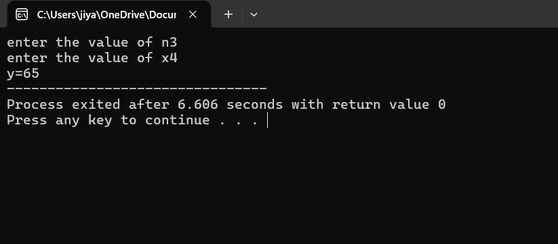
#include<stdio.h>
int main()
{
int x,n,y;
printf("enter the value of n");
scanf("%d",&n);
printf("enter the value of x");
scanf("%d",&x);
if(n==1)
y=1+x;
else if(n==2)
y=1+(x/2);
else if(n==3)
y=1+(x*x*x);
else if(n>3 || n<1)
y=1+(n*x);
printf("y=%d",y);
}

Question-25
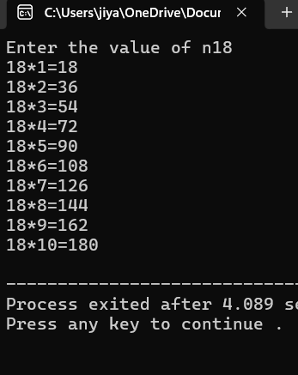
#include<stdio.h>
int main()
{
int n,i,table;
printf("Enter the value of n");
scanf("%d",&n);
for(i=1;i<=10;i++)
{
table=n*i;
printf("%d*%d=%d\n",n,i,table);
}
}

Question-26
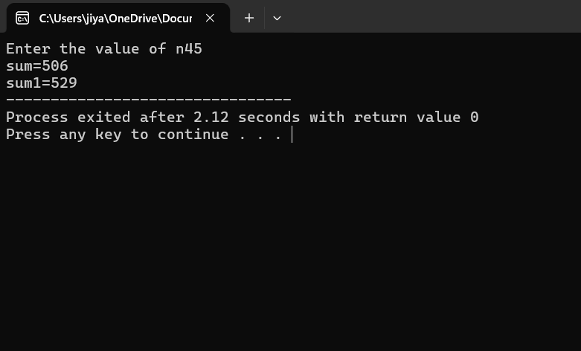
#include<stdio.h>
int main()
{
int n,sum=0,sum1=0,i;
printf("Enter the value of n");
scanf("%d",&n);
for(i=1;i<=n;i++)
{
if(i%2==0)
sum=sum+i;
else if(i%2!=0)
sum1=sum1+i;
}
printf("sum=%d\n",sum);
printf("sum1=%d",sum1);
}

Question-27
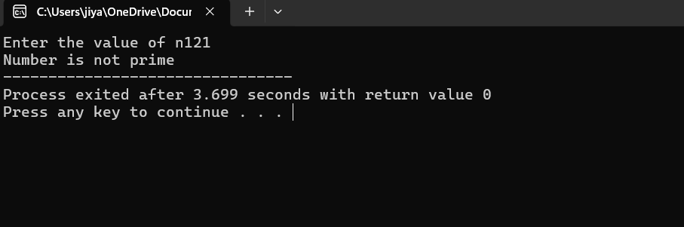
#include<stdio.h>
int main()
{
int n,i,is_prime;
printf("Enter the value of n");
scanf("%d",&n);
if(n<0)
printf("number is not prime");
for(i=2;i<n;i++)
{
if(n%i==0)
is_prime=0;
}
if(is_prime)
printf("Number is prime");
else
printf("Number is not prime");
}

Question-28
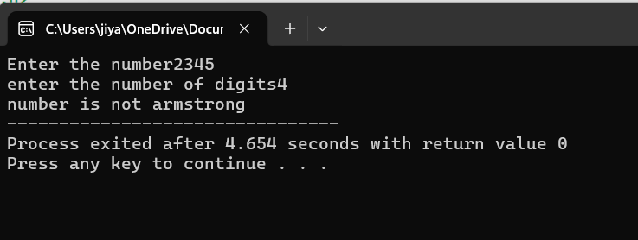
#include<stdio.h>
int main()
{
int n,sum=0,x,num,j,q,i;
printf("Enter the number");
scanf("%d",&n);
printf("enter the number of digits");
scanf("%d",&j);
num=n;
while(n!=0)
{
x=n%10;
q=1;
for(i=1;i<=j;i++)
{
q=q*x;
}
sum=sum+q;
n=n/10;
}

if (sum==num)
printf("number is armstrong");
else
printf("number is not armstrong");
}

Question-29

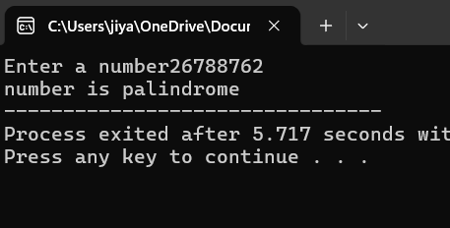
#include<stdio.h>
int main()
{
int n,x,sum=0,num;
printf("Enter a number");
scanf("%d",&n);
num=n;
while(n!=0)
{
x=n%10;
sum=sum*10+x;
n=n/10;
}
if(sum==num)
printf("number is palindrome");
else
printf("number is not palindrome");
}

Question-30
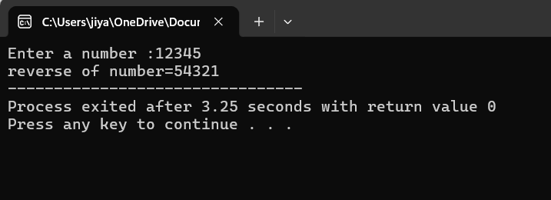
#include<stdio.h>
int main()
{
int n,x,sum=0,n1;
printf("Enter a number :");
scanf("%d",&n);
while(n!=0)
{
x=n%10;
sum=sum*10+x;
n=n/10;
}

printf("reverse of number=%d",sum);
}
Question-31
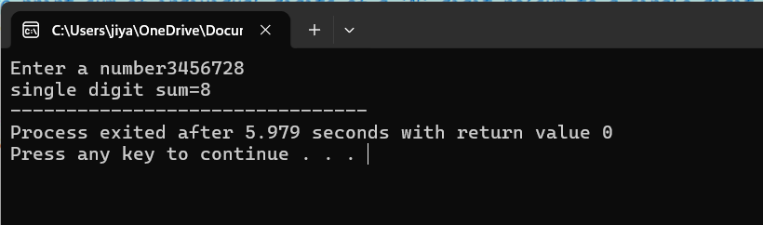
#include<stdio.h>
int main()
{
int n,sum=0,x,num,result=0,y;
printf("Enter a number");
scanf("%d",&n);

while(n!=0)
{
x=n%10;
sum=sum+x;
n=n/10;
}

while(sum!=0)
{
y=sum%10;
result=result+y;
sum=sum/10;
}
printf("single digit sum=%d",result);
}

Question-32
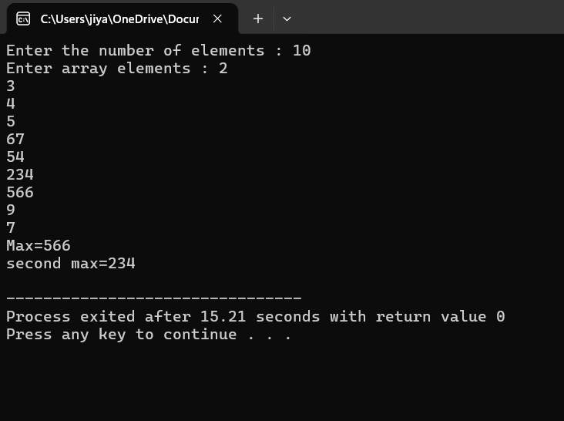
#include<stdio.h>
int main()
{
int n,a[100],i,max,smax;
printf ("Enter the number of elements : ");
scanf("%d",&n);

printf("Enter array elements : ");
for(i=0;i<n;i++)
{
scanf("%d",&a[i]);
}
max=a[0];
smax=a[0];

for(i=1;i<n;i++)
{
if(a[i]>max)
{
smax=max;
max=a[i];
}
else if(a[i]>smax&&a[i]<max)
{
smax=a[i];
}
}
if(max==smax)
{
printf("second max does not exist");

}
else
{
printf("Max=%d\n",max);
printf("second max=%d\n",smax);
}
return 0;
}
Question-33
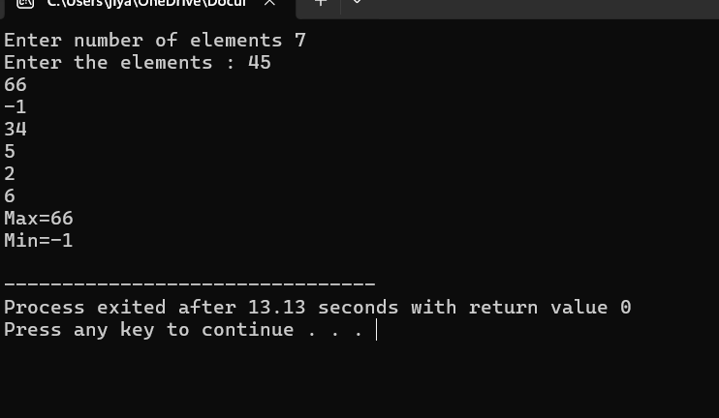
#include<stdio.h>
int main()
{
int a[100],n,i,max,min;
printf("Enter number of elements ");
scanf("%d",&n);

printf("Enter the elements : ");
for(i=0;i<n;i++)
{
scanf("%d",&a[i]);
}
max=a[0];
min=a[0];

for(i=1;i<n;i++)
{
if(a[i]>max)
{
max=a[i];
}
if(a[i]<min)
{
min=a[i];
}
}
printf("Max=%d\n",max);
printf("Min=%d\n",min);
return 0;
}

Question-34
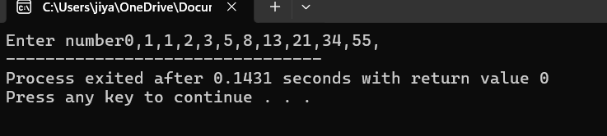
#include<stdio.h>
int main()
{
int n,i,x=0,y=1,z;
printf("Enter number");
for(i=0;i<=10;i++)
{
printf("%d,",x);
z=x+y;
x=y;
y=z;
}
}

Question-35
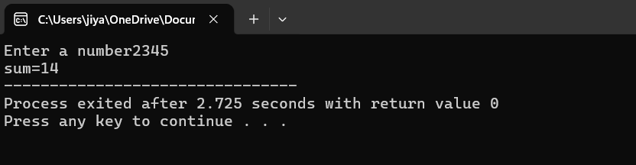
#include<stdio.h>
int main()
{
int n,sum,x,ysum1=0;
printf("Enter a number");
scanf("%d",&n);
while(n!=0)
{
x=n%10;
sum=sum+x;
n=n/10;
}
printf("sum=%d",sum);
}

Question-36
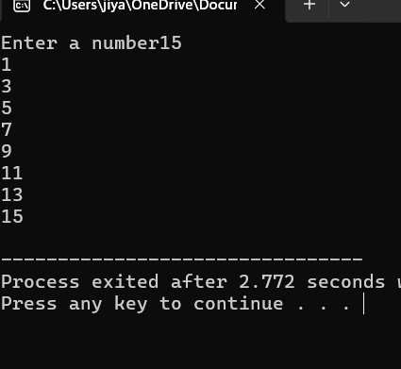
#include<stdio.h>
int main()
{
int n,i;
printf("Enter a number");
scanf("%d",&n);
for(i=1;i<=n;i++)
{
if (i%2!=0)
printf("%d\n",i);
}
}

Question-37
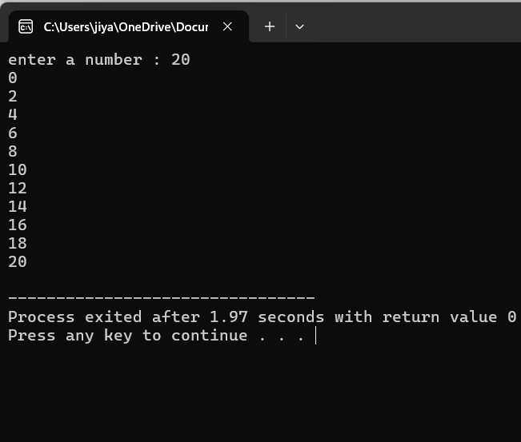
#include<stdio.h>
int main()
{
int n,i;
printf("enter a number : ");
scanf("%d",&n);
for(i=0;i<=n;i++)
{
if(i%2==0)
printf("%d\n",i);

}
}
Question-38
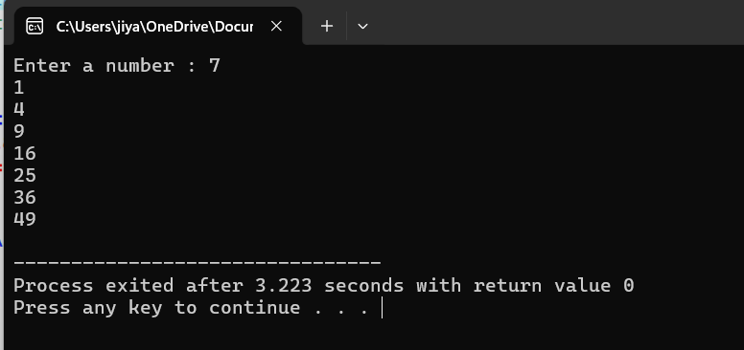
#include<stdio.h>
int main()
{
int n,i,x;
printf("Enter a number : ");
scanf("%d",&n);
for(i=1;i<=n;i++)
{
x=i*i;
printf("%d\n",x);
}
}
Question-39
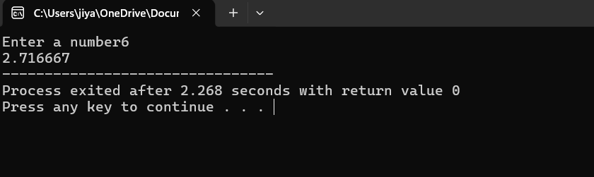
#include<stdio.h>
int main()
{
float n,i,fact=1,x;
printf("Enter a number");
scanf("%f",&n);
for(i=1;i<=n;i++)
{
fact=fact*i;
x=x+i/(fact);
}
printf("%f",x);
}

Question-40
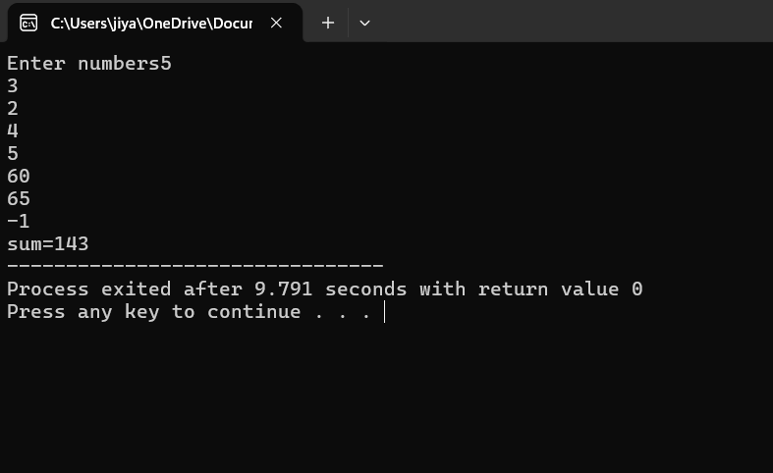
#include<stdio.h>
int main()
{
int n,sum=0;
printf("Enter numbers");
while(n>=0)
{

scanf("%d",&n);
sum=sum+n;
}
printf("sum=%d",sum);
}

Question-41
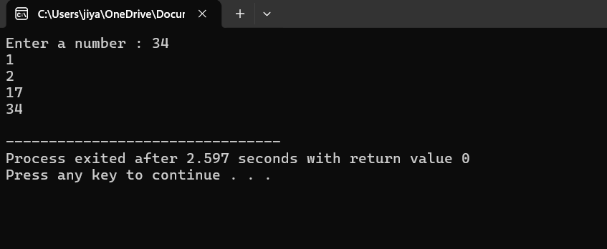
#include<stdio.h>
int main()
{
int n,i;
printf("Enter a number : ");
scanf("%d",&n);
for(i=1;i<=n;i++)
{
if(n%i==0)
printf("%d\n",i);
}
}

Question-42
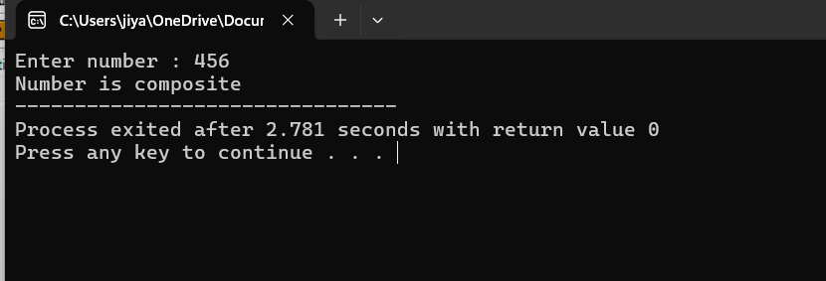
#include<stdio.h>
int main()
{
int n,i,is_prime,is_composite;
printf("Enter number : ");
scanf("%d",&n);
for(i=2;i<n;i++)
{
if(n%i==0)
is_composite=1;
else
is_prime=1 ;
}
if(is_composite)
printf("Number is composite");
else if(is_prime)
printf("number is prime");

}

Question-43
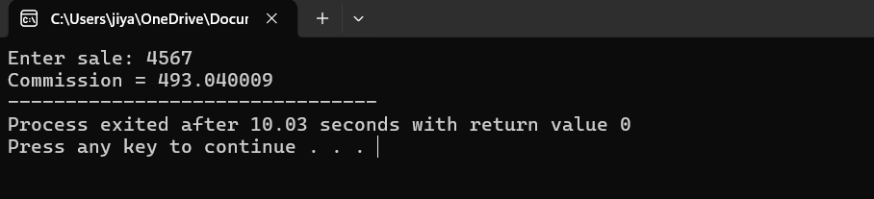

#include<stdio.h>
int main()
{
float sale,c,sale0;

printf("Enter sale: ");
scanf("%f",&sale0);

if(sale0<=500){
c=(sale0/100)*5;
printf("Commission = %f",c);
}
else if(sale0>500&&sale0<=2000){
c=((sale0-500)/10)+35;
printf("Commission = %f",c);
}
else if(sale0>2000&&sale0<=5000){
c=((sale0-2000)/100)*12+185;
printf("Commission = %f",c);
}
else{
c=(sale0/100)*12.5;
printf("Commission = %f",c);
}

}

Question-44
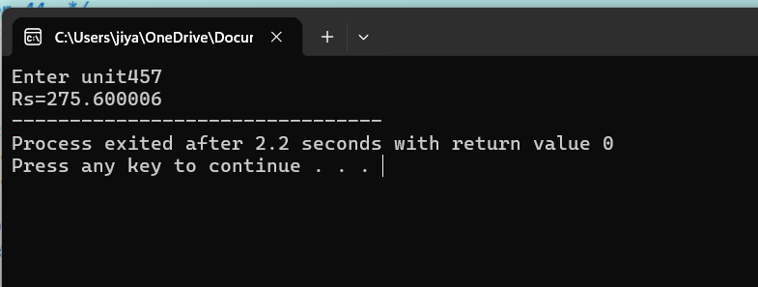
#include<stdio.h>
int main()
{
float unit,rate;
printf("Enter unit");
scanf("%f",&unit);
if(unit>=0 && unit<=200)
{
rate=unit*0.50;
printf("Rs=%f",rate);
}
else if(unit>=201 && unit<=400)
{
rate=100+(unit-200)*0.65;
printf("Rs=%f",rate);
}
else if (unit>=401 && unit<=600)
{
rate=100+130+(unit-400)*0.80;
printf("Rs=%f",rate);
}
else if(unit>600)
{
rate=425+(unit-600)*1.25;
printf("Rs=%f",rate);
}
}

